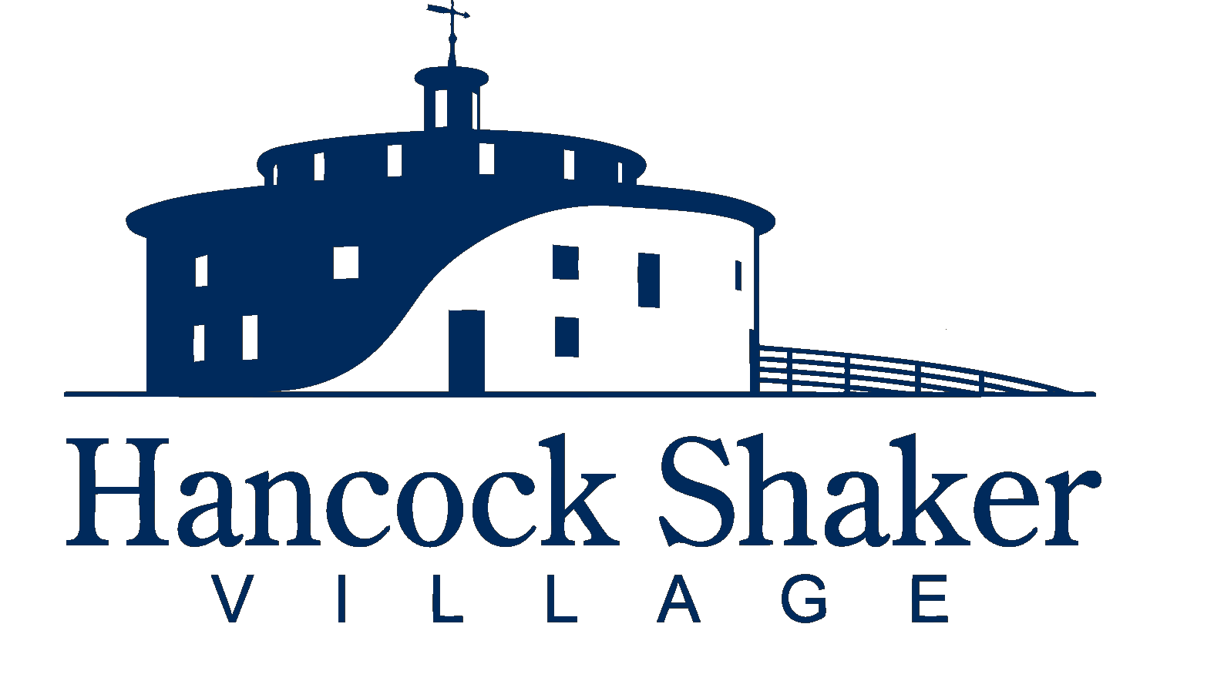

**Hancock Shaker Village | Development Program Director**

**Summary Position Description**

The Development Program Director (DPD) is a key member of the leadership team of Hancock Shaker Village (HSV). The DPD works with the Director and other members of the HSV leadership team to ensure that development strategies are aligned with the mission, vision and values of HSV; lead, manage and execute the day-to-day activity of all development operations; and deliver financial results across government, foundation, corporate and individual fundraising.

The DPD is responsible for developing, managing, and executing our organizational development objectives to include fundraising, donor relations, cultivation activities, campaigns, fundraising events, data management, and reporting. This includes the Annual Fund/Shaker Society, Memberships, Sponsorships, Business Partners, Grants and other contributed income. With the support of the development staff, the DPD is responsible for securing key contributed income amounts to help underwrite annual operating expenses, special programs, restricted programs, endowment, and capital projects.

Hancock Shaker Village’s Development Program Director oversees and manages our contributed income donor programs and initiatives. They represent HSV to a broad spectrum of funders, community leaders and external stakeholders -- this includes strategic communication, community-building and related activities to further the goals of HSV. This role is responsible for developing and implementing multi-year growth plans for contributed income programs in collaboration with the Director of Engagement, Director of Finance and the Director/CEO. The successful candidate will be expected to support all other development-related functions across the Village operations as needed, including but not limited to, special donor events, strategic communication, program planning and the Annual Summer Gala.

**Key Functions**

*Development Strategy*

* Create and implement a comprehensive annual fundraising strategy to support the mission, vision and operating needs of HSV.
* Develop and implement an institutional giving strategy for the solicitation of major gifts, foundation, government grants and individual donors.
* Support the development of a strategy and business plan to identify new and current sources of funding for the capital campaign.
* Create and implement a comprehensive fundraising capital campaign strategy for supplemental campaigns.
* Support the development and implementation of a strategy for cultivation, stewardship and solicitation of new Board of Trustees members.

*Data Management*

* Provide up-to-date reporting, tracking and administrative requirements for all institutional, corporate and individual donor relationships.
* Ensure accurate, up-to-date data management of the donor database and provide reports for both regular performance tracking and special projects as needed.
* Provide comprehensive updates, tracking and maintenance of the fundraising database, including membership lists, records and fundraising calendar.
* Project annual revenue and develop, secure and track income streams through earned income, rentals and sales.

*Donor Relations*

* Identify, cultivate, increase and renew grants, gifts, memberships, sponsorships and contributions from institutional partners.
* Support the planning, organization and execution of special events for solicitation and cultivation purposes, including HSV’s Annual Gala, regular fundraisers, year-round donor engagement and cultivation events, patrons’ tours and trips, and exhibition receptions and previews.
* Draft and create reports to funders on all funded projects.
* Create, coordinate, edit and deliver proposals, correspondence and appeal letters to all funding sources.
* Oversee government relations and support from government sources at the local, agency, state, federal and international levels.
* Supervise research on prospects for all potential funding sources, including government, foundations, corporations and individuals.

*Management*

* Strategize and define departmental goals, set timelines, and track progress for yourself and your team.
* Identify the scope of work and delegate responsibilities and guidance to department staff.
* Provide the development team with guidance, continuous feedback and constructive criticism as needed through regular communication and meetings.
* Formally review staff performance on an annual basis with regular check-ins throughout the year.
* Mentor and supervise department staff, fellows, and interns; work with HSV leadership to identify and support professional development opportunities.
* Model exemplary workplace behavior in alignment with HSV mission, vision, and values; take proactive steps to enhance an organizational culture of learning, inclusion, and cross-departmental collaboration.
* Work in alignment with all HSV policies and procedures and ensure department staff has knowledge and access to resources to do the same.
* Oversee outside consultants engaged for development.

*Partnership*

* Attend interdepartmental meetings to promote clear communication, coordination, situational awareness, planning, and other key functions.
* Build strong relationships with Trustees and supporters and support governance and Board solicitation relationships -- including managing the Development, Governance, Annual Gala and Campaign Committee meetings.
* Prioritize regular, consistent and constructive communication across all levels of the organization.
* Work closely with all members of the HSV team to support inter-department requirements, reporting, strategies and operations.
* Actively participate in team meetings and encourage dialogue, attend events and industry gatherings and support colleagues across programming, operational and special event requirements.

*Budget and Finance*

* Provide support to the Director, Finance Director and other members of the leadership team on the annual budget preparation, maintenance, tracking all project budgets.
* Monitor and update monthly, quarterly, and annual projections based on revenue, expenses and other budgetary factors.
* Develop and maintain department budget and forecast inputs for each fiscal year.
* Develop, maintain and support contributed income pipeline, actuals and projection data.
* In coordination with the Director and Finance Director, produce fundraising updates and projections for internal team tracking, Board of Trustees, proposals, fundraising initiatives and other similar efforts.

**Qualifications**A dynamic colleague who thinks, writes and acts strategically and successfully to fund programs, initiatives and communications that advance the Hancock Shaker Village mission and institutional values. The ideal candidate has development or sales program experience and has the ability to initiate and enjoy direct communication with donors, prospects, members and colleagues.

The successful candidate will have a passion for the arts, design, history, and/or the Shakers; enjoy being a member of a close-knit team; and thrive in a nimble, fast-paced environment. The below qualifications are preferred:

* Excellent verbal, writing and time management skills; comfortable working on multiple projects and meeting new challenges with keen attention to details.
* Bachelor’s degree and demonstrated experience in development within an arts and cultural organization, with demonstrated fundraising success, or equivalent combination of relevant skills and experience.
* Experience with donor database software as well as the Microsoft suite.
* Experience in data analytics and reporting.
* Familiarity with best practices related to donor, membership, grants, and sponsorship programs.
* Excellent interpersonal communication skills, a hospitality-forward engagement style, and ability to engage effectively with a wide range of personalities.
* Ability to work flexible schedule in order to attend / lead events and programs that may occur outside of the core working hours (such as weeknights, holidays, and weekends).
* High attention and adherence to confidentiality and non-disclosure of sensitive personal and financial information.
* Enthusiasm for a fast-paced and evolving environment.

**Hancock Shaker Village is an equal opportunity employer and considers all candidates for employment regardless of race, color, sex, age, national origin, creed, disability, marital status, sexual orientation or political affiliation.**

**About Hancock Shaker Village**

Hancock Shaker Village is a landmark American heritage destination comprised of 750 acres, 20 historic Shaker building, and nearly 30,000 Shaker artifacts. On the National Historic Register, it is the most comprehensively interpreted Shaker site in the world, and the oldest working farm in the Berkshires of Western Massachusetts.

The mission of Hancock Shaker Village is to bring the Shaker story to life and preserve it for future generations; to collect and preserve the property and artifacts that demonstrate the history, industry, life, and traditions of the Shakers and their achievements/contributions to the American way of life; to exhibit the collections of Shaker buildings, furnishings, libraries, and objects of art; to enable and conduct studies and research into Shaker and American community history; and to reflect on living a principled life and the values the Shakers embraced: integrity, racial and gender equality, pacifism, community, sustainability, responsible land stewardship, innovation, and simplicity. Through multifaceted programming in art, music, food, and thought, we share the Shaker story, and strive to ignite curiosity, expand imaginations, and inspire generations.

Interested candidates should send a letter of interest and copy of their resume to: [info@hancockshakervillage.org](mailto:info@hancockshakervillage.org). Thank you!