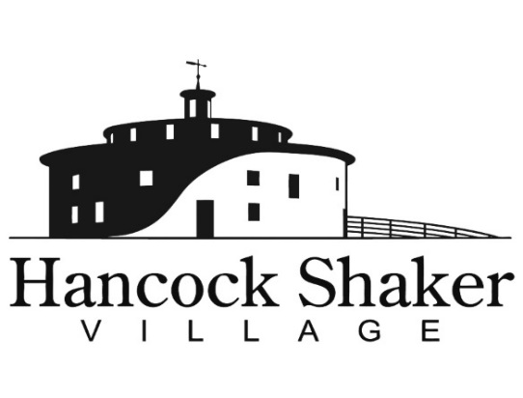
PRESS CONTACT:
Carolyn McDaniel
cmcdaniel@hancockshakervillage.org
413.443.0188 x221

THE BIG CHILL IS BACK

PITTSFIELD, MASSACHUSETTS, February 4, 2022 – Hancock Shaker Village welcomes visitors on Sunday, February 20 for The Big Chill - a day of winter fun.

“Like all New Englanders, the Shakers of Hancock embraced the winter months – and so do we,” says director Jennifer Trainer Thompson. “The Berkshires in the winter can be magical. Come enjoy a day of exploring traditions and winter fun.”

The Big Chill is an action-packed day of old-fashioned winter fun from 11AM to 4PM.
Activities will include maple tree tapping, ice-harvesting talks and ice sculpting, visits with farm animals in the Round Stone Barn, blacksmithing and woodworking demos, snowman making, live music, and more.

Country music band Wild Bill and the Flying Sparks will take the stage in the Believers' Room for two afternoon sets. Bring your snowshoes and hike the Village Farm & Forest Trail and South Family Trail. Ice harvests, once an essential part of winter in rural communities, will be explored by ice-harvesting expert Dennis Picard using historic tools and techniques. Today, ice is not only essential for keeping items cold, it is also used as a medium for artists creating intricate sculptures that reflect and refract the light like glass. Watch as two accomplished ice carvers, Peter Vacchina and Bob Markey, create remarkable pieces of art while chipping away at 300-pound blocks of ice. And, if all that ice and snow makes you yearn for something sweet, Andy and Trish from Windsor Hill Sugar House will demonstrate maple tapping on our large specimen tree near the Sisters Dairy and Weave Shop with their syrup and other products available for purchase in Shaker Mercantile.

Planned activities include:

- Maple tapping demonstrations – 11:30, 1:30
- Live music – 1:30, 3:30
- Guided walking tours of Village – Noon, 1:00, 2:00, 3:00
- Ice talks – 12:30, 2:30
- Ice sculpting demonstrations (throughout the day)
- Story Walk The Mitten by Jan Brett—in the Round Stone Barn (throughout the day)
- Scavenger Hunt—throughout the Village (throughout the day)
- Snowshoeing/hiking on the Farm and Forest Trail (throughout the day)
- Blacksmithing demonstrations (throughout the day)
- Woodworking demonstrations (throughout the day)
- Snow fun—build a snowperson, make a snow angel, do a snow craft, play snow games (hula hoop snowman toss)--throughout the property
- Farm Animals in and out of the barn—frolicking in the snow, warming up in the Dairy Ell (throughout the day)

Warm up by the bonfire and enjoy lunch or a beverage from Bimi’s Café. The bar will be open for wine, Big Elm Beer, and mulled cider.

The Big Chill is part of Pittsfield’s Office of Cultural Development 10x10 Upstreet Arts Festival. All activities are included in admission; $15 per person, free to members and children 12 and younger.

Hancock Shaker Village is located at 1843 West Housatonic Street in Pittsfield Mass. For more information about Hancock Shaker Village, please contact Carolyn McDaniel at cmcdaniel@hancockshakervillage.org or visit HancockShakerVillage.org.

###

