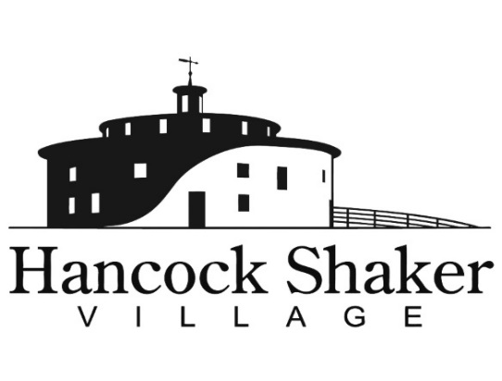
PRESS CONTACT:
Carolyn McDaniel
cmcdaniel@hancockshakervillage.org
413.443.0188 x221

HANCOCK HOLIDAY NIGHTS
15 Wonderfilled Nights in December

Historic village shimmers with light projections, holiday surprises, live animals, and more

PITTSFIELD, MASSACHUSETTS, November 15, 2021 – This December, the oldest Shaker Village in New England will sparkle in a new multi-sensory month-long experience called Hancock Holiday Nights. Enjoy five stunning art light projections that immerse you in wonder as the holiday spirit fills the air. Stroll through the 19th-century New England setting transformed with festive decorations. Say goodnight to donkeys, sheep, and other live animals in the barn. Discover Shaker holiday traditions that ran deep. Preview never-before-seen Shaker miniatures. Gather with friends for holiday cocktails and cheer by a festive fire. The happiest time of the year is filled with light, sound, wonder, food, adult beverages, and a cozy fire. Let time slow and your spirits rise in this new Berkshire tradition.

“If you’ve never experienced Hancock Shaker Village at night, you’re in for a treat,” said Hancock Shaker Village Director Jennifer Trainer Thompson. “There is an exquisite beauty, a palpable peacefulness and sense of wonder. We are thrilled to celebrate the holiday spirit.”

New England charm, combined with light displays, music, other sensory experiences, and an opportunity to say goodnight to the animals, will set apart Hancock Shaker Village, which is celebrating its 61st year as a museum.

Hancock Holiday Nights runs December 2 through 5, December 9 through 12, and December 16 through 19, and December 27 through 29. Tickets are $20 for adults, $10 for kids 6-18, and free for five and under. Advanced purchase of timed tickets is required. (Tickets are not required for children ages 2 and younger.) Entrance to the Village is ticketed in 15-minute increments between 5 and 8PM. Tickets can be purchased HERE.

In the spirit of the season, those who wish may bring a simple gift of new hats, coats, or mittens to be donated to Berkshire Community Action Council.

HANCOCK HOLIDAY NIGHTS HIGHLIGHTS

Timber Frame of Wishes – The Timber Frame entrance becomes a wonderland of lit trees capturing visitor wishes.

Luminous Wonder – Illuminated projections by artist Joe Wheaton.

Lantern-light Strolls - Experience the charm of Hancock Shaker Village by lantern-light, strolling past candlelit buildings.

Goodnight Barn – Visit with our farm animals tucked into their stalls for the night.

The Mercantile – Shop for Shaker-inspired artisanal gifts and decor.

Festive Fire & Bar – Warm up around our fire pit while you enjoy delicious adult and kid beverages.

Hancock Holiday Nights is sponsored by Mill Town and Hill Engineers, Architects, Planners, Inc.. Light art projections created by Joe Wheaton. Fragrance provided by ScentBridge.

INCLUDE NIGHTTIME BARN PHOTO WITH CAPTION: Hancock Shaker Village’s Round Stone Barn will be aglow and the animals await you at Hancock Holiday Nights, running through December 29, 2021

INCLUDE FESTIVE GOAT PHOTO WITH CAPTION: Visit Hancock Shaker Village’s farm animals as they ring in the new Hancock Holiday Nights, running through December 29, 2021

Hancock Shaker Village is located at 1843 West Housatonic Street in Pittsfield Mass. If you would like more information about Hancock Shaker Village, please contact Carolyn McDaniel at cmcdaniel@hancockshakervillage.org or visit HancockShakerVillage.org.

###

