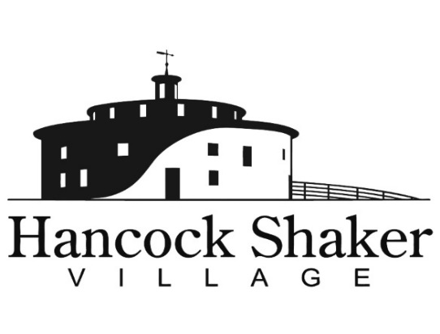
PRESS CONTACT:
Carolyn McDaniel
cmcdaniel@hancockshakervillage.org
413.443.0188 x221

FOOD FOR THOUGHT
MAKE IT NICE WITH DORINDA MEDLEY

PITTSFIELD, MASSACHUSETTS, September 2, 2021 – Our popular Food for Thought dinner series is back! Welcoming authors ranging from Stacy Schiff to Elisabeth Kolbert to discuss far-ranging subjects of relevance or interest today, Hancock Shaker Village’s Food for Thought kicks off on Saturday, September 11, with Real Housewives of New York City fan-favorite Dorinda Medley talking about her latest book, Make It Nice.

Throughout her life, Medley has always strived to “make it nice” regardless of circumstances. In this funny, candid memoir, Medley unveils the not-so-glamorous bumps in the road that have marked her roller-coaster journey, chronicling her childhood in the Berkshires, marriage and motherhood in New York and London, and her return to the Berkshires to renovate Blue Stone Manor in Great Barrington.
A story of love, motherhood, loss, and looking life straight in the eye by the TV personality audiences worldwide adore, Make it Nice tackles many life lessons and the benefits of working hard, dished up with Medley’s trademark humor and wit. Dorinda Medley is a TV personality, entrepreneur, entertainer, philanthropist, and mother. You may know her from The Real Housewives of New York City, but she is also known for “making it nice” and takes great pleasure in entertaining and decorating for the holidays and other special occasions at her home in the Berkshires, Blue Stone Manor.

Dinner with Dorinda will be held outdoors under the Timberframe, with magnificent views of the farm and Round Stone Barn. Dinner will highlight heirloom produce from our Shaker gardens. The seasonal event includes the farm-to-table dinner, wine, and a copy of Medley’s book, which she will be available to autograph. Saturday, September 11th at 6pm, limited seating. Tickets $100/per person or $190 per couple (https://hancockshakervillage.org/events/food-for-thought/).

Hancock Shaker Village’s Food For Thought series is sponsored by October Mountain Financial Advisors.

Hancock Shaker Village is located at 1843 West Housatonic Street in Pittsfield, Mass. For more information about Hancock Shaker Village, please contact Carolyn McDaniel at cmcdaniel@hancockshakervillage.org or visit HancockShakerVillage.org.

###

