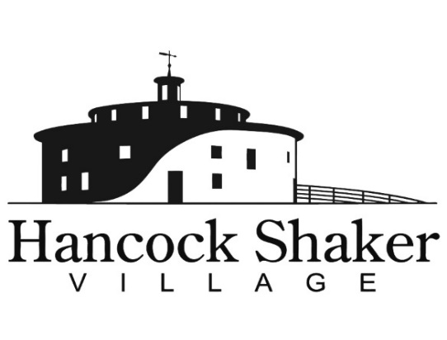
PRESS CONTACT:
Carolyn McDaniel
cmcdaniel@hancockshakervillage.org
413.443.0188 x221

COMMUNITY DAY AT HANCOCK SHAKER VILLAGE
OFFERS FREE ADMISSION FOR ALL

PITTSFIELD, MASSACHUSETTS, November 8, 2021— Hancock Shaker Village announces its annual Community Day will take place on Sunday, November 14 from 11 am to 4 pm. Admission is free all day.

Fun activities for all ages include a Where the Wild Things Are story walk with Berkshire Athenaeum, craft demonstrations, a scavenger hunt, interpreter led talks and walks, plus visits with the barnyard animals. All buildings in the historic village are open for exploration and several special exhibitions, including Tory Burch: Beauty Rests on Utility, Gary Graham: Looking Back to Look Forward, Thomas Barger: Heaven Bound, Local and Land Made: Growing a New Textile Economy, Climbing the Holy Hill, and Notes About Home: 60 Years at Hancock Shaker Village are in the last month to view. The accessible, one-mile Farm and Forest Trail, including the newly revealed South Family Trail, is also open.

In addition to free admission for all, Hancock Shaker Village is pleased to make our programs accessible to the Spanish-speaking members of the community with the assistance of an on-site interpreter and a Spanish language audio tour available through a smartphone app.

Community Day at Hancock Shaker Village is made possible by the generous support of Mill Town. Additional support from the Massachusetts Cultural Council Festivals Program. And with thanks to the Berkshire Food Co-op.

Hancock Shaker Village is located at 1843 West Housatonic Street in Pittsfield Mass. If you would like more information about Hancock Shaker Village, please contact Carolyn McDaniel at cmcdaniel@hancockshakervillage.org or visit HancockShakerVillage.org.

###

