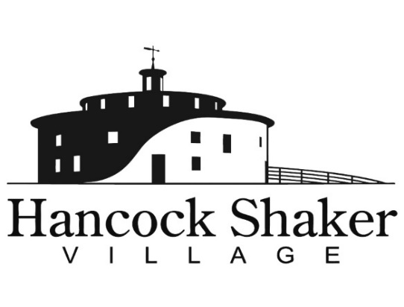
PRESS CONTACT:
Carolyn McDaniel
cmcdaniel@hancockshakervillage.org
413.443.0188 x221

24th ANNUAL COUNTRY FAIR COMING TO HANCOCK SHAKER VILLAGE
Tradition, craftsmanship, food, music, and family fun highlight the weekend

PITTSFIELD, MASSACHUSETTS, September 15, 2021 – The 24th Annual Country Fair, an iconic autumn event in the Berkshires, will be held at Hancock Shaker Village on Saturday, September 25 from and Sunday, September 26 from 11 am–5 pm. With dozens of vendors, new art installations, workshops and demonstrations, and family activities, the weekend offers something for everyone. Most activities, unless otherwise noted, are included with admission.

HIGHLIGHTS
- Local and Land Made: Growing a New Textile Economy featuring 19th Century Shaker wool-working tools from the Hancock Shaker Village collection. Also on view are contemporary garments created from locally and sustainably sourced wool and alpaca from New York Textile Lab and 100% wool from Western Massachusetts Fibershed. The textile products created from this rich collaboration of farmers, spinners, and designers embody holistic values without sacrificing the human need for beauty, creativity, comfort, and design. Celebrate the past, present, and future of sustainable textiles in our region, on view in the Brick Poultry House
- Drop-in Demonstrations: Early American craft demonstrations including Timber Framing, Tinsmithing, Oval Box making, Blacksmithing, Spinning, and Weaving.
- Irish Dancing: Come see performances by Scoil Rince Bréifne Ó Ruairc at 1PM and 3PM on Sunday 9/26.
- AND MUCH MORE, including: Artisanal crafts, antique tractor exhibition, craft beer, local food vendors, farm stand, pony rides, an animal exhibit, and face painting.

Country Fair is sponsored by TD Bank, Balance Rock Investment Group, Greylock Federal Credit Union, and Price Chopper / Market 32.

Hancock Shaker Village is located at 1843 West Housatonic Street in Pittsfield Mass. If you would like more information about Hancock Shaker Village, please contact Carolyn McDaniel at cmcdaniel@hancockshakervillage.org or visit HancockShakerVillage.org.

###

